
Development Request
Aria Systems
Custom programs for Entitlements amendments to SOP
(ISSUE 123847)

New Program Template Description

New Program Template

New Program Header
Product: | Aria 27
Module: | SO
Customer name: | Tip Top Computers
Installed Modules: | AL, AR, GL, IC, PO, SO, RM, SR
Parameters setting: | Extended Sizes, Multi Warehouse

A. ENTITLEMENTS
Existing Initial situation: the user supplies garments to the Corporate Wear Sector where each employee has a yearly/18 monthly entitlement of garments. This new screen allows the user to set up each entitlement and the sales order rules that apply.

Description (Processing):

There will be 3 new files created:

A) Uniform Code File:

This will need the following fields –

Field Length Notes
UCODE 12 a/n Primary Key
UDESC 30 a/n Free format description
STYLE CSTYMAJOR
COLOUR Style colour code
Entitlement type either U=Units V=Value P=Points
Line No 2 numeric
Link to Line no 1 2 numeric
Link to Line no 2 2 numeric
Link to Line no 3 2 numeric
Start Date date Date record was created
End Date date Date record is valid to
Entitlement Calculation period 3 numeric

The user will need a screen to enter these details – where they enter a Ucode and have the standard Aria options of ADD, BROWSE etc. or if the code already exists then it is displayed as follows:

Uniform Code: xxxxxxxxxxxxxxx Desc: Chubb Warehouse Man
Date Created: 99/99/99 Valid to Date: 99/99/99

(This is followed by the following list )

Line No Style Colour Desc Points value Entitlement Link to Line
(1) (2) (3) (4) [ ] (5) [ ] (6) [ ] (7)

Add Delete Save Clear Close

Fields Notes

1) Line No Line No on screen
2) Style CSTYMAJOR
3) Colour Colour Desc from Codes file
4) Desc Style.desc
5) Points value This field only applies if Entitlement type is set to P and indicates the number of points 1 unit of the style/colour is worth
6) Entitlement If Entitlement type has been entered as U for Units, then a quantity can be keyed (no decimals). If type has been entered as V for value then a value can be keyed (2 decimal places). If P for points then a quantity can be entered here representing the number of points allowed for the style/colour (no decimals)

6) Link to Line Other style line nos that this style in linked to (see below)

The purpose of the link to style box is that a wearer may be allowed for example to order 5 shirts – but they could be from 2 separate styles – e.g. short and long sleeved. So the user will link the 2 styles and have the entitlement against both styles

All the normal tool bar options should apply.

Add – allows a new style/colour to be added from a style browse or entered direct.
Delete – Deletes a line from the table
Save – Saves the Entitlement
Clear – Clears the screen without saving and allows a new Entitlement code to be entered
Close – Closes the screen.

B) Employee/Wearer File:

This screen allows the user to give details of each Employee that works for them and what Uniform Code they are entitled to.

The fields that are required for the file are:

Field Length Notes
Acct x 5 customer.account
Location x 8 customer.store
Employee No x 12 input
Employee Name x 30 input
Employee ad1 x30 input
Employee ad2 x30 input
Employee ad3 x30 input
Employee ad4 x30 input
Employee ad5 x30 input
Payroll No x20 input
Site No x 10 input
Uniform Code x 12 from Uniform Code file as in point (A)
Start Date 99/99/9999 This will be the start date of the current entitlement period relevant to when the employee is entered on the system and will be used to calculate the period end date for new employees
Calculation period (3 numeric) This field represents the number of months determining the entitlement period for checking
Period End Date: DD/MM/YY

To enter a new employee the user will select a valid Customer Account Code – and if required a Customer Store Code. The user will then be able to either enter a new employee code with the standard Add, Browse, Clear options or select an existing employee from a browse that will only show employees already linked to the customer or customer/store selected.

The Screen will display as follows:

Customer Acct – xxxxxx (1) xxxxxxxxxxxxxxxxxxxxxxxxxxxx (2)
Location - xxxxxx (3) xxxxxxxxxxxxxxxxxxxxxxxxxxxx (4)

Employee No: xxxxxxxxxx (5) xxxxxxxxxxxxxxxxxxxxxxxxxxxxxxxxx (6)
Xxxxxxxxxxxxxxxxxxxxxxxxxxxxxxxxxxx (7)
Xxxxxxxxxxxxxxxxxxxxxxxxxxxxxxxxxxx (8)
Xxxxxxxxxxxxxxxxxxxxxxxxxxxxxxxxxxxxxx (9)
Xxxxxxxxxxxxxxxxxxxxxxxxxxxxxxxxxxxxxx (10)
xxxxxxxxxxxxxxxxxxxxxxxxxxxxxxxxxxxxxxxxx (11)

Payroll No xxxxxxxxxxxxx (12) Site No: xxxxxxxxxxx (13) Start Date DD/MM/YYYY (14)
Uniform Code xxxxxxxxxx (15) xxxxxxxxxxxxxxxxxxxxxxxxxxxxxxxx (16)
Entitlement Calculation Period: 999 (17)
Period End Date: DD/MM/YY (18)

(17) The entitlement calculation period is picked up from the Uniform file but can be edited for the employee. This represents the number of months for the calculation of the entitlement period
(18) Period End Date. This field represents the end of the current entitlement period and is calculated automatically by taking the Start date and adding the value of months keyed in the Entitlement calculation period field. For example, if an employee is entered today with a start date of 01/01/2004 and the Entitlement calculation Period is 18, then the Period End date would be calculated as 30/06/2005.
All the fields below the location are input fields and the only field to be validated is the Uniform Code – which must be a valid uniform code record as per point A) and can be picked from a browse of that file. It is also OK to leave the Uniform Code blank.

The usual tool bar options should apply. On the Options menu should be a 2 options called –

a) Style History b) Transaction History
This information will be held in a new transaction file called Employee History which will be written to from Sales Orders, Invoicing and Credit Memos.

a) Style History – this is a browse of all the styles that this employee has ordered
b) Transaction History – this is a browse of all Invoices and Credit Notes for the Employee Selected

The file layout for Style History would be:

Employee Code, Style, Colour, Entitlement, Used ,Last Order Date,
(the updates to this file are documented in the next section)
so the browse would be:
The entitlement used field should be editable for start up as when the system is implemented there will be a previous used figure to be keyed for the current entitlement period. The entitlement Used field can be a quantity or value field depending on whether Entitlement type = Points, Units or Value
Style, Colour, Style Desc, Entitlement, Entitlement Used , Balance to Use (Entitlement less Entitlement Used and this could be negative) – Last Order Date, currency. Code, exchange rate
The entitlement used is updated when a packing list is confirmed. This will occur when the packing list is scanned related to a sales order for the employee and a new field ‘Despatch date’ will be updated DESPDATE on packing list file. The Used quantity will be reduced where a credit memo has been keyed linked to an employee. See page 11 for explanation on Credit memos
The File layout for the Transaction History would be:

Trans Type (Invoice or Credit Memo), Employee Code, Style/Col/Size, Trans No, Trans Date,
So the browse would be:

Trans Type, Trans Date, Trans No, Style , Colour Desc, Size Desc, No of Units, Units Value base currency, currency of transaction, exchange rate, currency unit value.

Order Entry Entitlement Screen:

The user will enter a new order as per standard by selecting a customer/store etc,.
There will be a new option on the Detail Folder called – Entitlement Order.
If the user selects this option they will be prompted for an Employee Code – which can be entered or selected from the Employees that are linked to the Account and/or Store code that has been selected - no other Employees should be shown. They should also have the facility to add a new employee as defined in the Employee file above.
There should also be a new Customer User Definable field called “Check Entitlement’s ? Yes/No”.
If Check Entitlement is set to Yes on the employee file, then once the employee is entered on this screen, the system should check the order entered date against the Period end date on the Employee file. If the order entered date is greater than the Period end date on the employee, then the Period end date on the employee file should be updated to the next period end based on the Entitlement calculation period. The Entitlement Used figure should also be cleared from the Employee history file. This should be updated immediately before the user continues to enter styles on the order. If the Order entered date is less than the Period end date then no updates to the period end date and Entitlement Used will occur at this point

A new field should be added to ORDLINE, field EMPLOYEE which will hold the employee code.

If the employee has a Uniform Code then the following screen will appear. If there is no Uniform Code then you are taken straight into the Quick Order Entry Screen and when the order is saved the Employee Transaction History File is still updated.

The prices are not shown on the screen but are picked up based on the Quick Order Entry Special Prices – see section D-Changes to the Customer pricing – if there is no special customer price set then the price is picked from Style.pricea.

The screen will load with all the Style options for that Employee based on his/hers Uniform Code as below:
Employee Code: xxxxxxxxxx (1) Site No: xxxxxxxxx (2) Start Date: 99/99/9999(3)
Employee Name: xxxxxxxxxxxxxxxxxxxxxxxx (4)

Style Colour Fit Size1 Size2 Size 3 Size 4 Size 5 Size 6 Size 7 Size 8 Size 9 Size 10 (6) Total (7)
Xxxxx xxxx xxxx 999 999 999 999 999 999 999 999 9999
(8) ( 09) (10) (11) (12)

There may be more than eight sizes for each fit (dimension 1). The screen should display up to 10 sizes and then have to move to the next sizes with the Style/Colour/Fit staying constant.
There will be a new user defined field on the style file called – STYLE.CSTYNOT (this already exists on the system as a 20 character field). As each style is selected if there is data in this field display it in a message box after the employee name in Red on a white background.

[Save] [Clear] [OTS] [Close] - Desc xxxxxxxxxxxxxxx Ent: 99 Used: 99 Balance: 99
(13) (14) (15) (16)
fields:
1 – Employee .Code
2 - Site No
3 - Entitlement Start Date
4 – Employee Name
5 – Headings
6 – Size Scale descriptions
7 – Heading
8 – Entitlement Style (cstymajor)
9 – Colour Desc from Codes File
10 – Fit – this is only printed where there is a 2 dimensional size scale and is the description from dimension 1
11 - input quantities
12 – line total
13 - Desc from the style being highlighted on the screen
14 – Entitlement Qty/Value/Points from Entitlement file for the style line being highlighted on the screen
15 – Entitlement used from the History file for the style being highlighted on the screen
16 – Difference between 14 and 15
Save – Saves changes
Clear – Clears Screen and allows to reinput
Close – goes back to Detail Folder
OTS – if you click on this button then the following information is displayed for the style highlighted on the screen:

Style Sizes 1- 10 total
OTS 1 -10 total
Component Sizes 1-10 total
OTS 1-10 total

The Style OTS is shown on the first line and if the BOM for that style includes any Style Components then the OTS for that Style Component are shown on the second line.
When a screen is saved – ORDLINE records are written that can be viewed BUT NOT EDITED in the standard Detail Folder before saving. If they want to make changes they must reenter the new Entitlement Order Screen to make the changes . If Ordlines have already been entered on a Sales Order then the Entitlement Order Screen should be unavailable.

If the new Customer User Defined Field “Check Entitlements “ on the Customer file is set to Yes then when the order line is saved the following checks should be made:
Check that the customer has enough entitlement left by checking that Entitlement Used and New Order Qty are not greater than the Entitlement Qty field. Remember that where 2 or more lines are linked then the entitlement is held against the style no that is linked to e.g.

Line No Style Col Entitlement Used Link to line no
5 ABC Green 5 2 7
7 DEF Green 5 1 5

If either if these styles were selected then when checking the Used figure for the calculation you would add the used from both styles to give you a total used of 3 – so that available entitlement for that order would be 2 pieces.
If the customer has enough entitlement then the Ordline is written with the input qty.

If the user has only a partial or no entitlement left then a message should be displayed to say that the user has gone over the entitlement on style xxxxx – please enter user code and password.
Remember that when checking the entitlement you have to look at the Uniform Code file to see which entitlement type they have – Units, Value or Points.
a) If it is units then just check the order qty + Used does not exceed the Entitlement for each line
b) If it is value then check that the value of the line + Used value does not exceed the entitlement value
c) If it is points then check that the quantity entered multiplied by the points value field for the style/colour on the Uniform code file + Entitlement Used does not exceed the Entitlement points ”.
When the sales order details have been keyed for an employee, then it should be possible to key a further employee on the sales order by clicking New at the employee prompt. When editing the sales order it should be possible to access the entitlements screen and select the employee already entered to edit the details or enter a new employee.
There will need to be a new system setting in the User system defaults “Allow authorization of Over Entitlements ? Y/N” – that can only be set by an administrator. If the user name and password is entered correctly then the Ordline is saved – if no user name and password is entered the Ordline is not saved.

Amendments to Returns Authorisation and Credit Memos for Entitlements:

When entering a Returns Authorisation – after entering the header details – you go to enter the details. If the RA has been linked to an sales order or invoice – then when entering the details we need to link each line of the RA to an employee to credit their entitlement.

So when the style has been entered – there should be a new entry on the Options button – “Select Employee” – when this is selected a list of all Employees who purchased that style on that Sales Order (which can get from the new Employee Transaction File as above) – are listed and the user selects an employee – so that when the RA is turned into a Credit Memo a new entry is written to the Employee History File. The system will also update the new Employee/Uniform Code file to reduce the Qty Used field – by either units, value or points – dependant on the flag set in the Uniform Code file.

B. AMENDMENTS TO SALES ORDER PROGRAM

Other changes required to Order Processing:
a) Customer PO:
Add a new user definable field to the Customer File called “Compulsory Customer PO ? Yes/No”. This field should default to “Yes”.
If it is set to Yes then the user cannot save a Sales Order unless the Customer PO field on the Order Header has been entered.

b) Calculation of Dates:
Add 2 new user fields to the Customer File:
i) “Add to Entered Date “ – a 2 character numeric field set to 0
When saving a new sales order – if the value of this field is greater than 0 than add this number of days onto the ORDHDR.ENTERED date to calculate the ORDHDR.START – the ENTERED date should not change.

ii) “Add to Start Date “ – a 2 character numeric field set to 0
When saving a new sales – if the value of this field is greater than 0 than add this number to Ordhdr Start date (after the calculation in point ii) to calculate the COMPLETE Date – the Start Date should not change.

c) Carriage Charge on Sales Orders:

The user needs the ability to add extra charges at the Sales Order Entry Stage.

Add 2 new user definable fields to he Customer File:

i) Charge Carriage ? Yes/No – default to No
ii) Minimum Order Value for Charging - 99999.99 – set to 0

Add a new entry to the Codes File called – Order Charges – which have the following fields:
Code – Order Description - Order Charge – customer account (s) (this is optional but if selected must be a valid account)
When saving a sales order where the user field charge carriage is set to Yes and the total order value is equal or less than the Minimum Order Value for charging – the user should be able to pick from a list of Order Charges (if there are Order Charges in the Codes file that are specific to that customer – then only those should be shown – if not order charges are specific to the customer then all those that are not assigned to a customer should be displayed) - and select the one they wish to apply to the order – at which time they can change the charge amount. .
This creates an entry to a new ORDCHARGE file that holds the Order no, Charge Code, Charge Amount, Invoiced (yes/no) set to No - which is picked up and used to create an INVCHRGE record when the Order is invoiced as long as the Invoiced field is set to No and is updated to Yes when invoiced.
There should be a new entry in the Options Menu on the sales order header Options “View Order Charges” – where the use can look at any charges on the order and if there are none there – add a new one, delete or edit one that exists as long as it has not been marked as invoiced.

d) Amend Custom Program 200236:
The customer will be using custom program 200236 – which auto allocates inventory based on settings in the Division related fields
Firstly there is a bug that needs to be fixed whereby the program is asking you if you want to allocate even when there is no stock available.
The user will have the setting set to Always Pick so that the question “Do you want to allocate” does not appear. If there is enough inventory to pick the whole order then it should be picked with no notification to the user. If the order can only be partially picked i.e. at least one item can be picked – then the user should be taken straight to the Sales Order Allocation screen with the Order Details pre-loaded and the options set to Pick.. The user can then amend the allocation and then save – which saves the changes and takes the user back to the Sales Order Entry Screen to enter a new order
*** Added 4th August by Tony *******

Firstly remember to take into account that they will be using the David Luke Bin Locaiton programs.

Also when saving an order or allocation if the order line being processed already has a Pick Ticket updated in the ORDLINE.PIKTKT field but there are still items outstanding on that line i.e. Ordline.qty > Ordline.Pik – and there is enough inventory to pick all or some of the outstanding balance – then prompt the user as follows:

“There is more stock available for style XXXXX that has already picked on this order – Do you want to a) Add to existing Picking ticket b) Create a new Picking Ticket “

If option a) is selected then the available Picking Tickets will be displayed and the user can choose on to add that Picking Ticket and increase the quantities picked on that lime – making sure to update the Style, Stydye etc. If option b) is selected the a new ORDLINE record will be created for the new quantities picked and updated with a new Piktkt reference. The Booked and Qty on the original ORDLINE will be updated accordingly and all the Style/Stydye updates carried out. This can happen to any Style in that Allocation.

These changes should also apply to the standard Sales Order Allocation program as well in the automatic picking from sales order.

*****************************************************************************

As a footnote to this – the standard Aria PO Cost Sheet screens for both manual and automatic issues/returns also needs to be changed so that when it is calculating the available stock to issue – it takes into account any Allocated Stock on Picking Tickets or with “******”.

C. CHANGES TO QUICK ORDER ENTRY SCREEN IN SO AND PO
f) Changes to custom programs 200431, 452,520, 551 and 587: :

i) Quick Order Entry Screen Layout:

The client uses extended sizes with 2 dimensions – so for example they have a size scale as below:
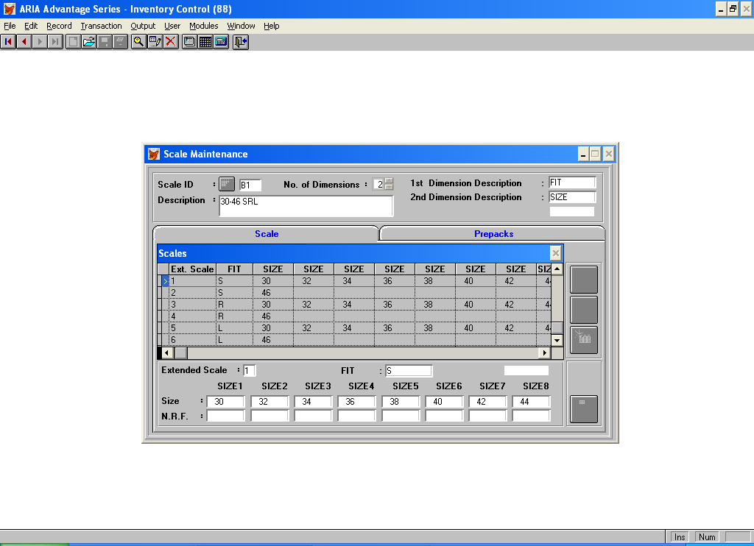
When a style with this size scale is displayed in the Quick Order Entry Screen then it appears as follows:

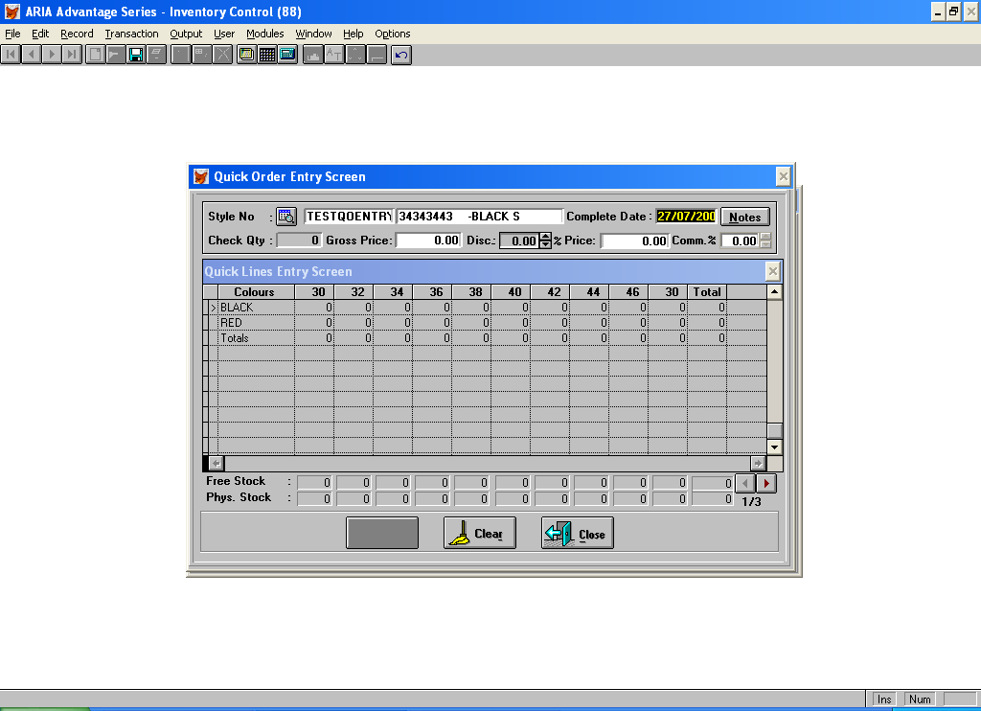

The sizes are being repeated across the screen for each Fit 3 times – what they want to see is as follows:
Colour/Fit 30 32 34 36 38 40 42 44 46
Black-S
R
L
Red - S
R
L

Also if a style being ordered has a style component on the BOM cost sheet – than add a line under Phys Stock that says Plain Stock - which shows the available style components with the calculation being Inventory less stock Allocated.

There will be a new user defined field on the style file called – STYLE.CSTYNOT (this already exists on the system as a 20 character field).

If there is text in this field do the following when the style is selected show this field in a message box on the bottom line next to the Close Icon (you can move the Icons further to the left if this is an issue) and please make the message Red on a White background

The current version of the Quick Order Entry screen for Purchase Orders picks up the correct prices only if Selected Values is determined by Scale code i.e. BOM.CITMMASK includes the scale code. DCC will not work this way. They will accept the default of colour for selected values. They may have separate prices for each colour in some case but not always. However, in the majority of cases they will tick Cost by size and when they have entered the price, they will have all scale codes available and will remove size records as required. The ‘Quick order entry screen ‘ needs to be modified to pick up the pricing by size on this basis

D. CHANGES TO THE CUSTOMER PRICING
ii) changes to the special pricing.

At the moment the CSTPRICE file holds a price for each size scale – this needs to be amended to be able to hold price by individual size. So you need to add 8 more fields to the CSTPRICE file – size1price to size8 price

The Special Pricing Screen currently looks like this:
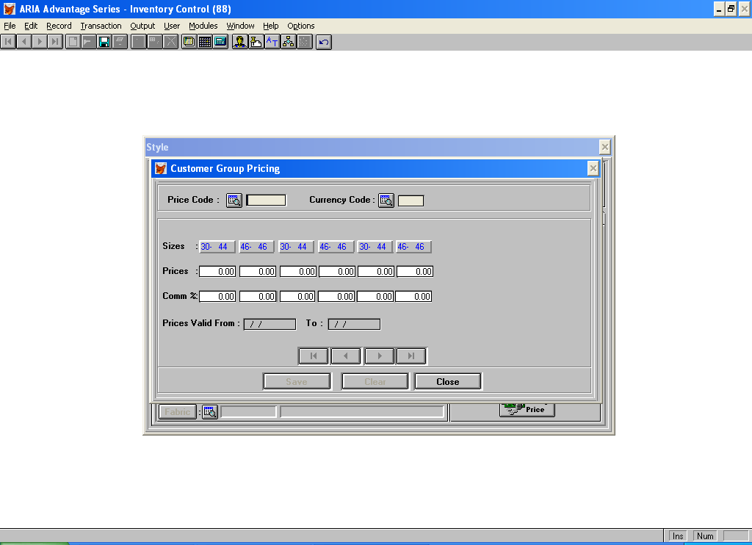
What needs to change is that you should be able to click on the sizes – e.g. 30-44 and another box will open up as below. If it is a 2 dimensional size code then the fits also need to be show
Fit 30 32 34 36 40 42 44
Small [ ] [ ] [ ] [ ] [ ] [ ] [ ]
Medium [ ] [ ] [ ] [ ] [ ] [ ] [ ]
Long [ ] [ ] [ ] [ ] [ ] [ ] [ ]

where prices by size can be entered to write to the new fields in the CSTPRICE field – but they can be left as 0.
So when an order is being placed where there is a price code set up for that style/customer – then if the individual size prices are 0 then you use the standard price for the size scale – but where a size has an individual price then that size price will be used.

E. CHANGE TO PO LINE BROWSE

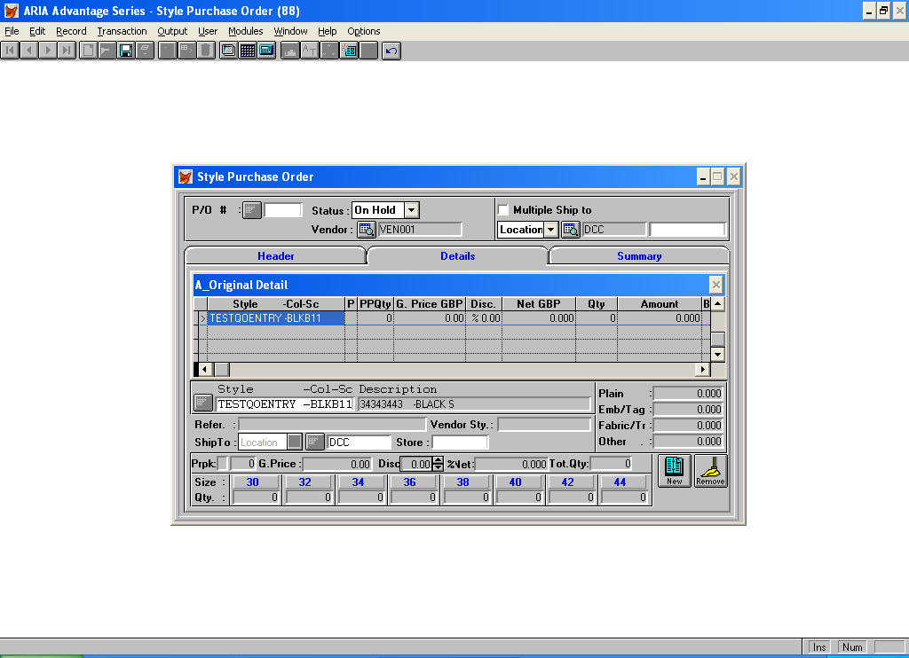

Add the Qty/Ctn from the Style file to the line headings in between PPqty and G.Price GBP.

**** added by Tony 4th August **********

As per section d) Amend Custom Program 200236 –

You need to take into account that they will be using the David Luke Bin Locations system .

Also they will need the new functionality to add to an existing Picking Ticket or create a new order line if necessary.

*******************************************************
Added by Tony: 4th August
Hi
There is a further request re this set of programs.
Part of the spec is to create a Uniform Code file. The client has alot of these codes already set up in an excel spreadsheet (copy attached).
They want a program to be able to import from this spreadsheet into the new Uniform COde file.
There is header on each line that says "Ucode 1" - for example and the number after the Code will be the UCODE no - after that all entries belong to that code until another line with Code in appears.
Field one is the STYLE (cstymajor)
Field 2 is the colour which matches to the colour descriotion on the COdes file
Field 3 is a style desc which can be ignored
Field 4 is the entitlement amount
The other fields in the new file would default to:
UDESC - spaces or possibly another column on the spreadsheet
COLOUR - is the Style Colour Code picked up from the colour description
Entitlement - = "U"
Line No - is a sequential no starting at 1 - which resets to 1 every time the Ucode changes
Link to Line nos fields - leave as 0
Start Date - System Date
End Date - leave blank

Questions and Answers:
Questions from Ashraf:
- In page 7 you mentioned:
"They should also have the facility to add a new employee as defined in the Employee file above."
How do you want to add the new employee, adding it on the fly with leaving all other fields empty or display the employee screen and let the user add it?
2- In page 8 you mentioned:
"(if a size scale changes then the new size scale should be displayed as a new line before the next style). If there are more sizes than fit on a screen - then have a arrow to move to the next sizes with the Style/Colour/Fit staying constant. "
I didn't understand this point, please give us an example.
3- In Page 20 you mentioned:
"Also they will need the new functionality to add to an existing Picking Ticket or create a new order line if necessary."
What do you mean?
Reply from Tony
Hi Ashraf
Re your points:
1) Display the employee screen
2) A Uniform COde will contain several different styles. One may be a jacket with sizes 30-32-34 etc. and one may be a sweatshirt with sizes Small Medium Large - so you will need to see the size scale for each style if different from the one displayed above.
A style might have more sizes than can fit on one screen (similar to the David Luke Production Planning screen - where the Style/Colour columns stay fixed but you can arrow to the next set of sizes) - the same would apply here with the Style/Colur/Fit staying constant adn an arrow to move to the next set of sizes.
3) This refers to the new amemdments on page 12 dated ** added 4th July - so that the new functionality on page 19/20 - also has the abiltity to add new orderlimes when the current ORDLINE.PIKTKT field already has a value.
Questions From Tarek
I have some questions regarding the new entry C#123847 for entitlement sales orders for DIR03.
1) The idea of linking styles is not clear for me
I need an example of a uniform code with 5 styles 3 of them are linked
Also, how to use the fields "Link to Line no 2" and "Link to Line no 3"
2) I think there is a field called "Entitlement" in the Uniform Code file that holds the entitlement of a style (- or linked styles)
Also, there must be a field on the related screen to enter Entitlement type
3) I understand the idea of 'Units' that an integer # of a certain style
What is meant by 'Value' and 'Points' as units of measure in this customization, I need an example for more clarification.
4) Can you send me the scale file of the customer DIR03?
5) For the Uniform code file
Can "Date Created" start in the middle of the month, e.g 13/1/2005 , also can "Valid to Date" be in the middle of the month e.g. 19/3/2005 If so how to calculate the period which is a number of monthes

Reply from Tony
a) Linking of Styles:

The basic principle is as follows:

Say there is a Uniform Code that has the following styles:
Assume in this case the Entitlement Type is U for Units

Style Colour Entitlement Link to Line
1111 Red 3 3 5
1112 Black 2
1113 Blue 3 1 5
1114 Black 2
1115 Red 3 1 3

The Styles 1111, 1113 and 1115 are linked – so that the entitlement over the 3 styles is a total of 3 units.
Therefore the Wearer – assuming the period of the entitlement is for one year – could order any of the following combinations of these styles as long as the total ordered is not greater than 3:

Either 3 @ 1111
2 @ 1111,and 1 @ 1113
1 @ 1111, 1 @ 1113 and 1 @ 1115

and so on for any combination of the 3 styles as long as the total ordered is not greater than 3.

b) Entitlement Types:

I understand the confusion here – (I got confused as well when I re-read the spec). Basically the information on page 3 – UCODE to - Entitlement Calculation Period are a header for that Uniform code and need a screen to enter them. This header holds the entitlement type. When this header has been created – you then enter the Styles that belong to that Uniform Code as per page 4 – so the Points Value or Entitlement entered here are controlled by the Entitlement Type entered into the Uniform Header.

c) Points and Value:

Points – If the entitlement type is set to Points then each style in the Uniform has a points value. E.g. style 1111 is worth 5 points. 1112 3 points etc, There needs to be added to the Uniform Code File – a field called Points Entitlement into which a value can be entered if the Entitlement Type is set to P. So that if this value was say set to 25 points – this is the number of points the Wearer is allowed in a year (or whatever the calculation period is). So if the Wearer had ordered say 2 1111 and 1 1112 he wuld have so far used up 13 points of his entitlement leaving 12 points left to use.

Value – IF the entitlement type is set to Value – then you need to add a field to the Uniform Code File called points value – which exactly as the Points above – but checks the value set against the style line in the Uniform Code.

5) It does not matter - say the Date Created was 19/01/2004 and the entitlement period was for 12 months then it would run out on the 18/01/2005.

Questions From Tarek
For Point 3

? At page#7, You said "The entitlement used field should be editable for start up as when the system is implemented there will be a previous used figure to be keyed for the current entitlement period"

I think the best way to enter this figure is to add a new option in the options pad menu with a browse of all styles of the uniform assigned to the the current employee This browse would be available only for the first time the uniform code is assigned to an employee and we can then edit the Entitlement used figure and is updated to the style history file when saving the added employee
Is this OK ?

Reply from Tony
Hi Tarek

If the entitlement type is Points or Value then the field is not style related so the figure scan be keyed in once.
If the entitlement type is Units them yes all the styles need to be displayed and the figures entered against each style.

Questions From Tarek
1- I have a question , you said in the specs page 13 under the title "Amend Custom Program 200236" the following :
"If there is enough inventory to pick the whole order then it should be picked with no notification to the user"
Note that there is an option for MBI “Add to existing Sales Order/Picking Ticket ? Yes/No”
do you mean to ignore this option and allocate the order in a new picktkt without displaying the browse that show all unprinted piktkts for the current account/store ?

2- Also for the needs labled by "*** Added 4th August by Tony *******"
I think this will happen only for edited orders , i.e. previously allocated but still there are some qty's not allocated
Is this correct ?
3- Also you said that in page 14
"As a footnote to this – the standard Aria PO Cost Sheet screens for both manual and automatic issues/returns also needs to be changed so that when it is calculating the available stock to issue – it takes into account any Allocated Stock on Picking Tickets or with “******”.""
Do you want to prevent issuing if the stock - picked is less than the qty needed to be issued per size ?
4- In Page 20
what do you mean by saying
"Also they will need the new functionality to add to an existing Picking Ticket or create a new order line if necessary."
5- In Page 7: What are the fields "Units Value base currency" , "currency unit value
6- In Page 6 you said :
The usual tool bar options should apply. On the Options menu should be a 2 options called –
a) Style History b) Transaction History
This information will be held in a new transaction file called Employee History which will be written to from Sales Orders, Invoicing and Credit Memos. "
I created two files STYHIST and TRNHIST
The second is updated when invoice or credit memo is saved
Do you need to add lines to the file TRNHIST when a sales order is saved

Reply from Tony
      - no take this into account – this client will probably always set the flag to NO – but other clients may set it to Yes “
      - Yes
      - This a bug that there has always been in Aria when issuing Style Components either Automatically or Manually from a PO Cost Sheet
If for example there are 100 pieces in inventory for a Style. 20 pieces of that style are allocated on a Picking Ticket that has yet to be invoiced. This style is also used as a style component on another style and there is a PO for that style that will require 90 pieces of the first style.
What the system now does is issue those 90 pieces from inventory against that PO Cost Sheet leaving 10 pieces in inventory. The the Picking Ticket is invoiced leaving a negative inventory of -10. So in other other words the system has created another 10 pieces of Inventory.
What should have happened is that the PO Cost sheet should have only allowed 80 pieces to issued (100 in inventory less 20 already picked) - so that it is not possible for the inventory to go negative.

      - Page 20:
In this custom program is a facility that if the system is going to add a Picking Ticket when saving the Sales ORder - (dependant on system setup flag being set in SO setups) - if there are already Picking Tickets for that Customer that have not been printed - then the user has the ability to add the new sales order to that Picking Ticket and SAles Order - rather than creating a new Sales ORder/Picking Ticket.

      - Page 7:
If the Transaction is in Foreign Currency then we want to see both the value in Base and Foreign Currency

6. This is fine - STYHIST is a record of Orders placed/cancelled and TRNHIST is a record of invoices/credit memos

